Student Internship Management System (SIMS)
Salesforce Phase 2 Project Report
Submitted by:
Cherala Sathwika
ACE Engineering College
Batch: 2022–2026

Abstract
The Student Internship Management System (SIMS) is a Salesforce-based solution designed to streamline the management and tracking of student internships. This project leverages Salesforce CRM capabilities such as Custom Objects, Relationships, Automation Flows, Reports, and Dashboards to simplify the process of recording student, company, and internship information. The system enhances transparency, reduces manual effort, and improves communication among students, mentors, and administrators.

Introduction
Internship management is a key activity in academic institutions, as it helps bridge the gap between theoretical knowledge and industrial exposure. However, tracking internship details, status updates, and company interactions manually can be tedious and error-prone. To address this issue, Salesforce provides an efficient cloud-based CRM platform where colleges can automate and visualize internship data.
This project, Student Internship Management System (SIMS), demonstrates how Salesforce can be customized to support the academic internship management workflow efficiently.

Problem Statement
Managing student internship data using spreadsheets or manual registers leads to data redundancy, lack of coordination, and delays in updates. Institutions often face difficulty in monitoring internship progress and generating performance insights. Hence, an automated, centralized system is required to manage and track student internships effectively.

Objectives
- To create a centralized Salesforce-based platform for managing student internships.
- To automate status updates and notifications using Salesforce Flows.
- To provide visual insights through Reports and Dashboards.
- To improve collaboration between students, mentors, and HR coordinators.

System Design
The SIMS application is designed using Salesforce declarative tools such as Object Manager, Flow Builder, and Report Builder. The main entities in the system are Student, Company, and Internship. Each of these is represented by a custom object, with relationships defined between them.

Custom Objects Setup
Three primary custom objects were created: Student, Company, and Internship. The Internship object connects the Student and Company objects through lookup relationships.
[Screenshot Placeholder: Custom Objects in Salesforce Object Manager]
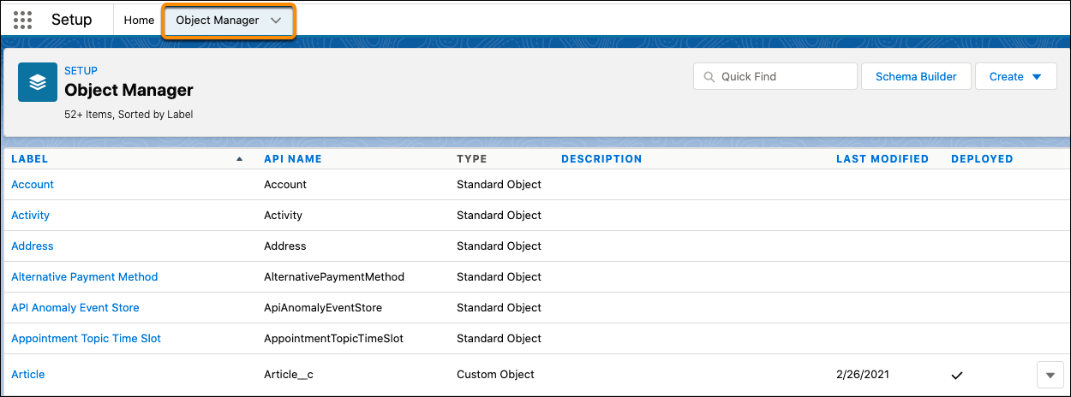

Relationships
The relationships ensure data consistency and allow viewing of internship details directly from Student or Company records. Lookup relationships enable flexible linking between objects without enforcing strict dependency.
[Screenshot Placeholder: Lookup Relationship Field Setup]
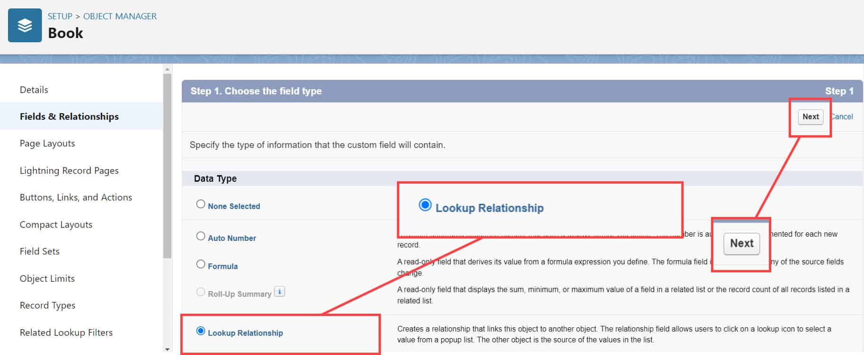

Automation using Flow
A Record-Triggered Flow was created to automate email notifications whenever an internship’s status changes to 'Completed'. This automation improves communication and reduces manual intervention.
[Screenshot Placeholder: Flow Builder showing Record-Triggered Flow]
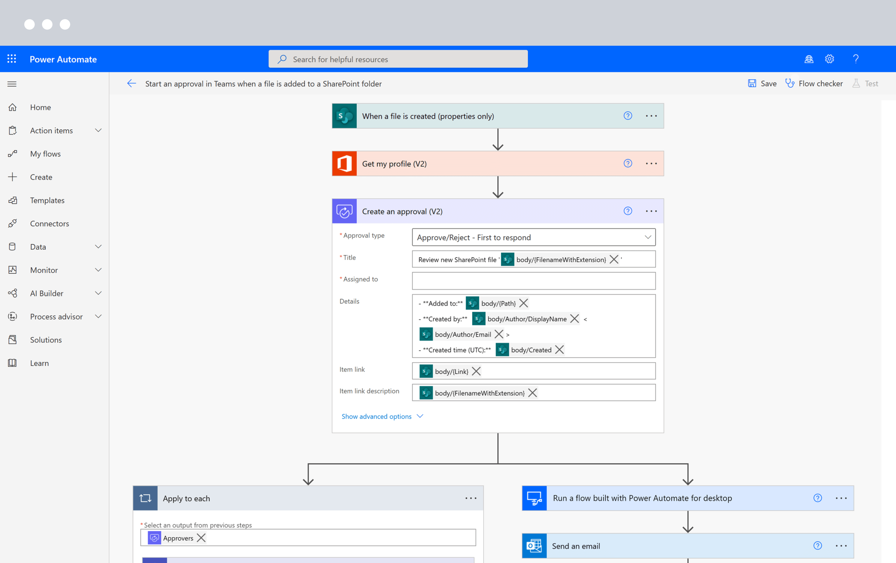

Reports and Dashboards
Reports were created to visualize internship data based on departments and completion status. Dashboards provide summarized charts and key performance metrics for the administration.
[Screenshot Placeholder: Internship Report and Dashboard View]
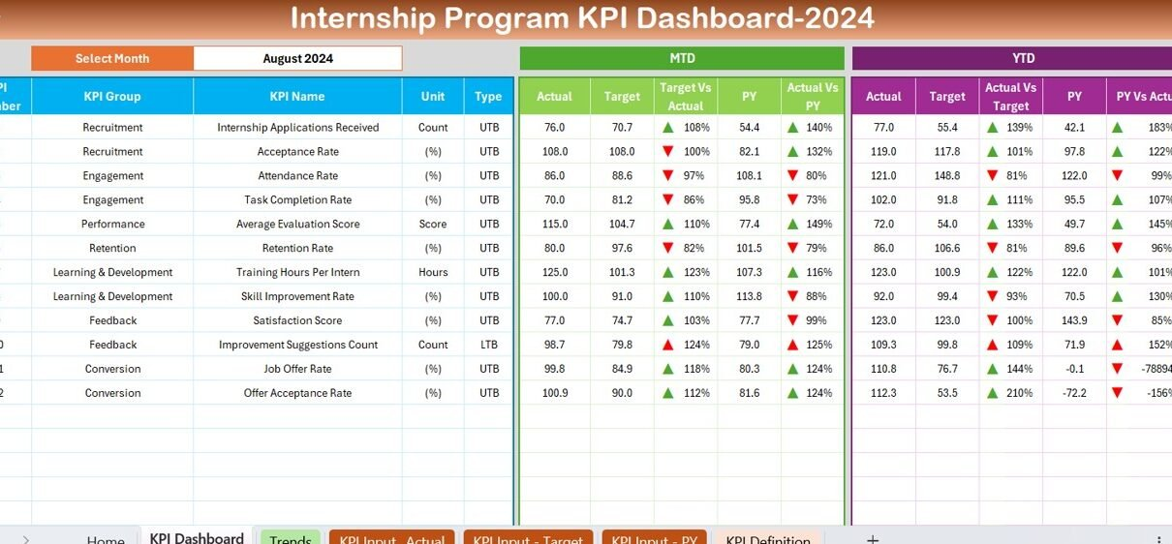

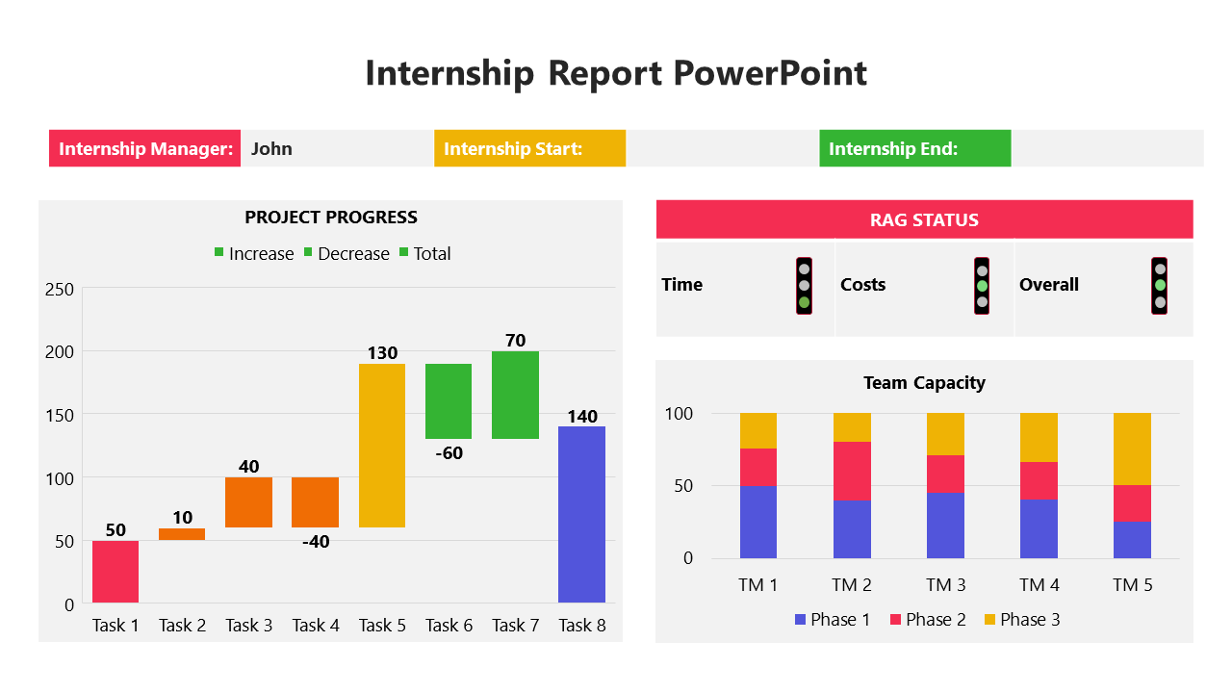

Results and Discussion
The SIMS project successfully demonstrates how Salesforce can be used to create an efficient internship management system. Users can easily add, update, and track internship data, while administrators can monitor overall progress through reports and dashboards. The automation ensures that key stakeholders are informed promptly about status changes.

Conclusion
The Student Internship Management System (SIMS) provides a reliable, scalable, and efficient way to manage student internships on the Salesforce platform. It enhances transparency, minimizes manual work, and provides real-time insights. This project highlights the potential of Salesforce for academic and administrative automation.

Future Scope
- Integration with placement and training records.
- Auto-generation of internship completion certificates.
- Adding approval workflows for internship verification.
- Extending access to external company partners for data entry and validation.

References
1. Salesforce Trailhead Modules – https://trailhead.salesforce.com
2. Salesforce Documentation – https://help.salesforce.com
3. SmartBridge TCS Salesforce Phase 2 Project Guidelines

